**DAILY ONLINE ACTIVITIES SUMMARY**

|  |  |  |  |  |  |  |  |  |
| --- | --- | --- | --- | --- | --- | --- | --- | --- |
| **Date:** | **09/06/2020** | | | | | **Name:** | **Spoorthy Balaji** | |
| **Sem & Sec** | **6th & B** | | | | | **USN:** | **4al17cs098** | |
| **Online Test Summary** | | | | | | | | |
| **Subject** | | **CGV and CNSC** | | | | | | |
| **Max. Marks** | | **CGV: 30**  **CNSC: 60** | | **Score** | | | **CGV: 28**  **CNSC: 44** | |
| **Certification Course Summary** | | | | | | | | |
| **Course** | **Introduction to Information Security** | | | | | | | |
| **Certificate Provider** | | | **Great Learning Academy** | | **Duration** | | | **6hours** |
| **Coding Challenges** | | | | | | | | |
| **Problem Statement:** 4 Programs | | | | | | | | |
| **Status: Solved** | | | | | | | | |
| **Uploaded the report in Github** | | | | | **yes** | | | |
| **If yes Repository name** | | | | | <https://github.com/spoorthybalaji/Daily_Status> | | | |
| **Uploaded the report in slack** | | | | | **yes** | | | |

IA TEST

**CGV**

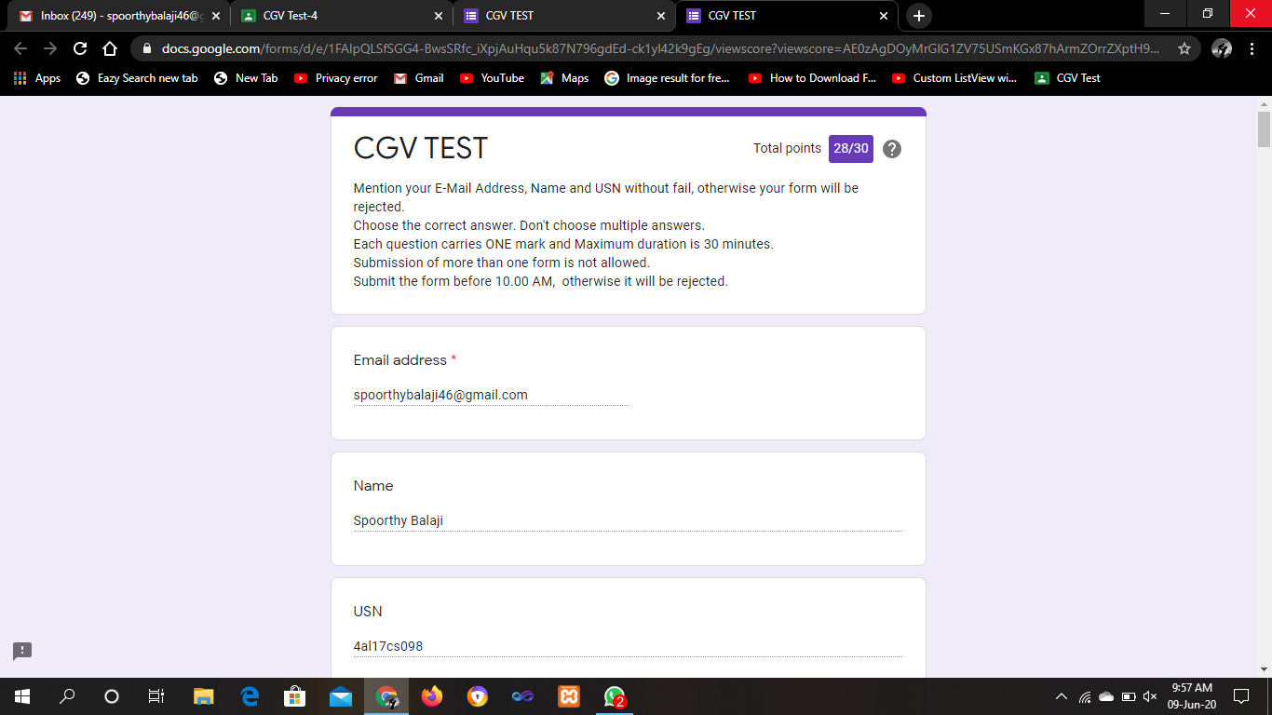

**CNSC**

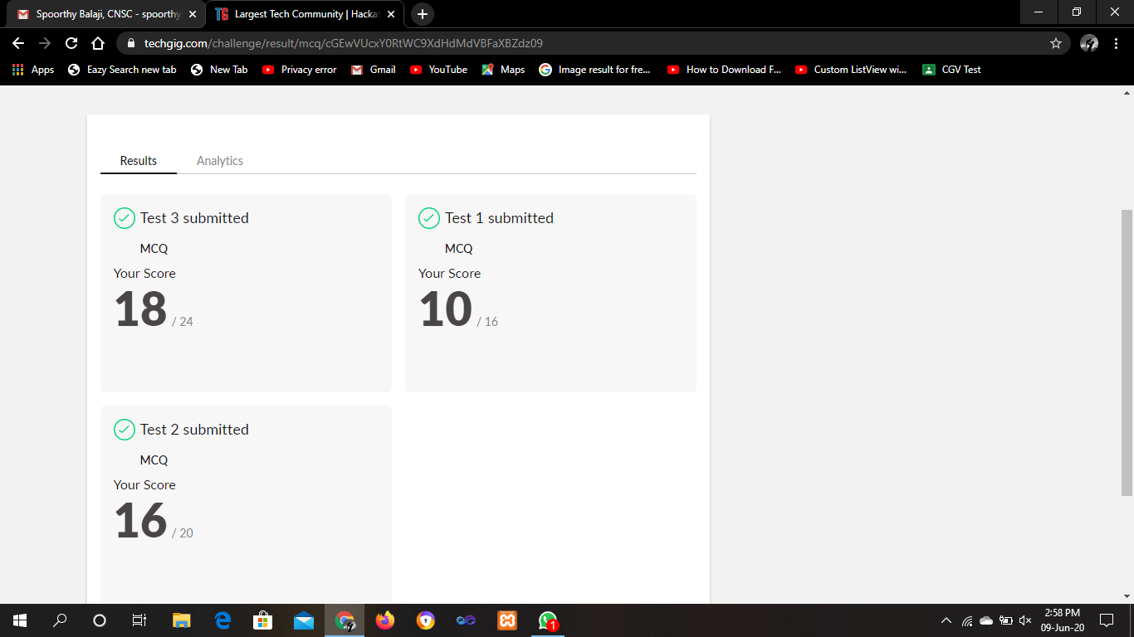

CERTIFICATION COURSE

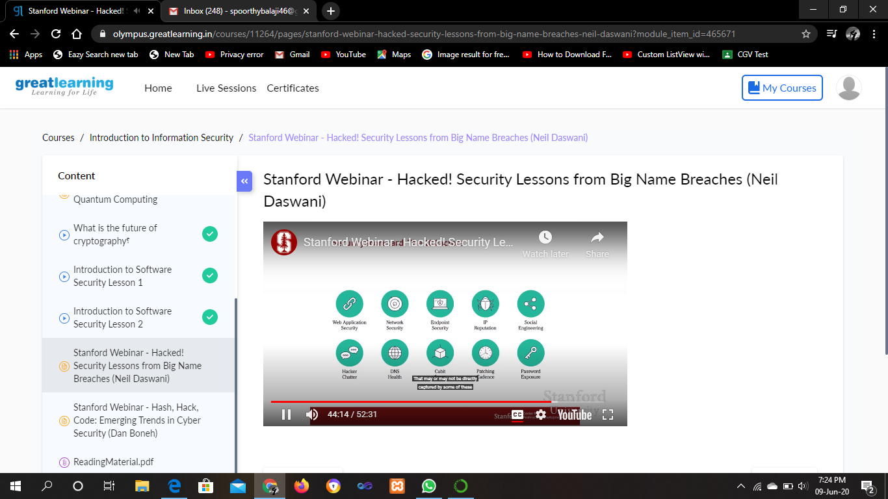

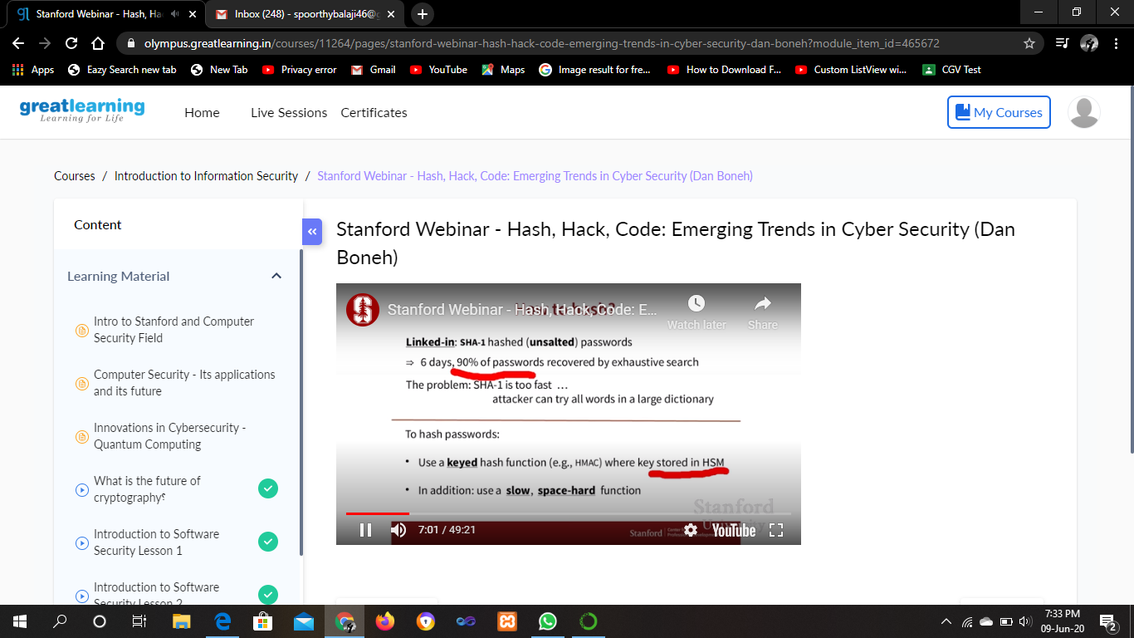

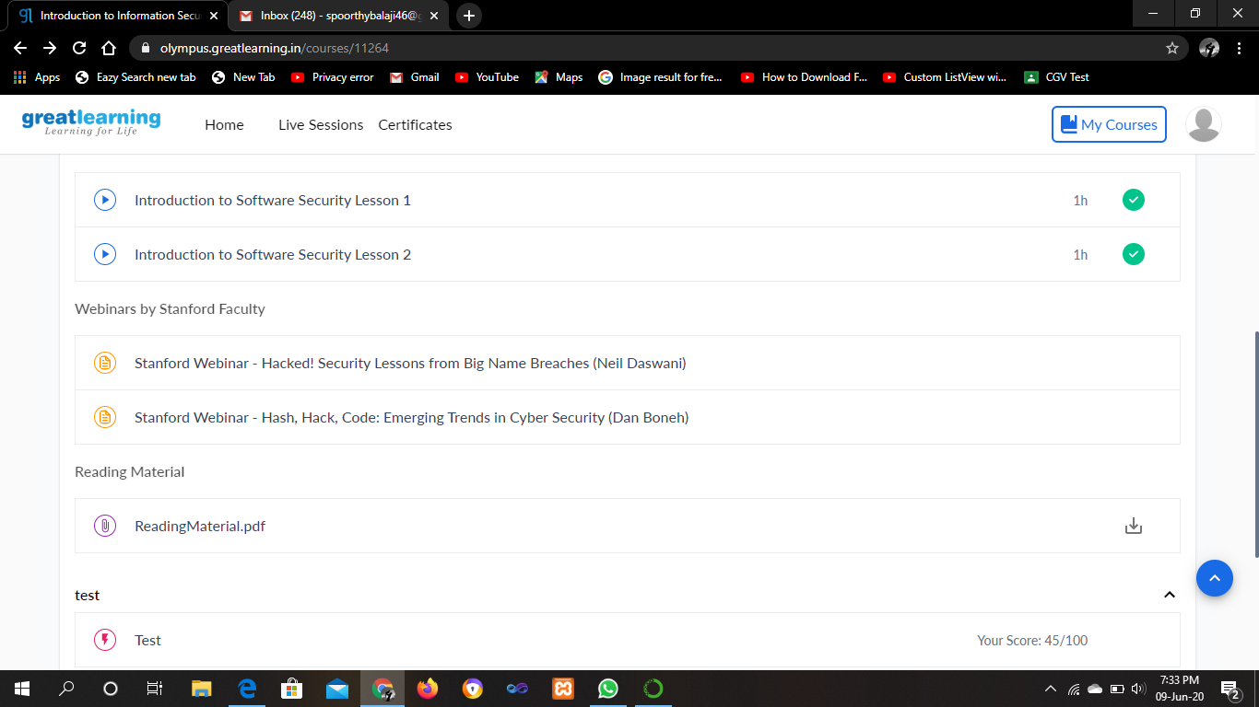

ONLINE CODING

**1. Write a Java Program to remove all white spaces from a string without using replace().**

**package**pblm;

**import**java.util.*;

**publicclass** pro2{

**publicstaticvoid** main(String[] args) {

Scanner s = **new** Scanner(System.***in***);

System.***out***.println("Enter The String:");

String str = s.nextLine();

**char**[] a = str.toCharArray();

String str1=" ";

**for**(**int**i=0;i<a.length;i++)

{

**if**(a[i]!=' ')

str1=str1+a[i];

}

System.***out***.println("Input String Without Spaces : "+str1);

}

}

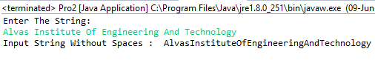

**2. Write a C Program to rotate the matrix by K times.**

#include<stdio.h>

int main() {

int matrix[100][100],M,N,k;

printf("Enter size of matrix\n");

scanf("%d%d",&M,&N);

printf("Enter the matrix elements\n");

for( int i = 0 ; i < M ; i++)

{

for(int j = 0 ; j < N ; j++)

{

scanf("%d",&matrix[i][j]); // Input the matrix elements

}

}

printf("Enter k value\n");

scanf("%d",&k);

int temp[M];

k = k % M;

for (int i = 0; i < N; i++) {

for (int t = 0; t < M - k; t++)

temp[t] = matrix[i][t];

for (int j = M - k; j < M; j++)

matrix[i][j - M + k] = matrix[i][j];

for (int j = k; j < M; j++)

matrix[i][j] = temp[j - k];

printf("The rotated matrix is\n");

for (int i=0; i < N; i++)

{

for (int j = 0; j < M; j++)

{

printf("%d ",matrix[i][j]);

}

printf("\n");

}

}

return 0;

}

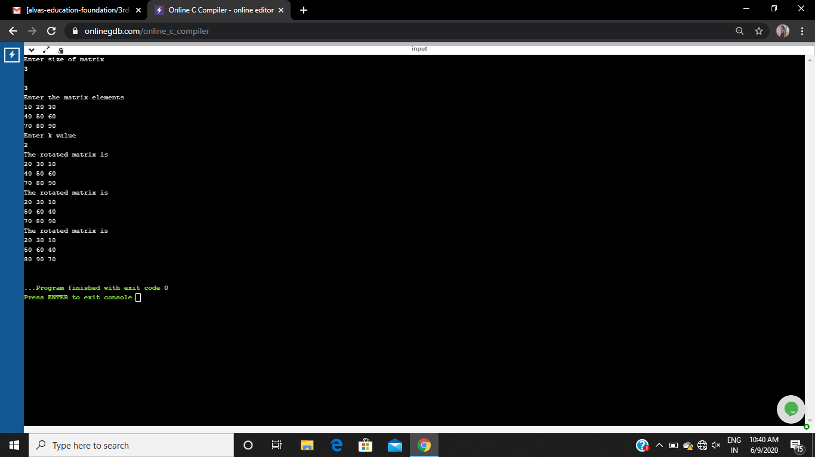

**3. Python Program to count even and odd numbers.**

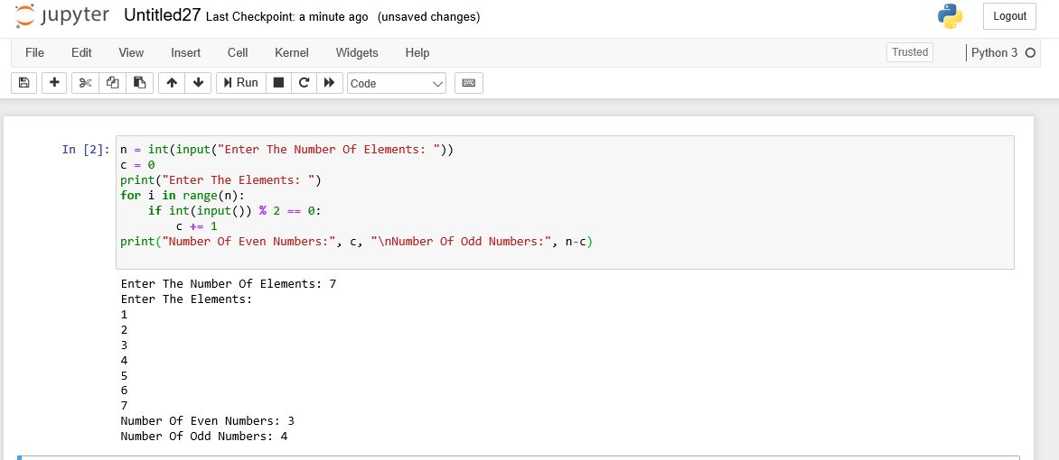

**4. Python program to reverse a string using recursion**

